Jack Lawrence Memorial
Baseball Tournament
9-10 Year Old Bracket; 11-12 Year Old Bracket

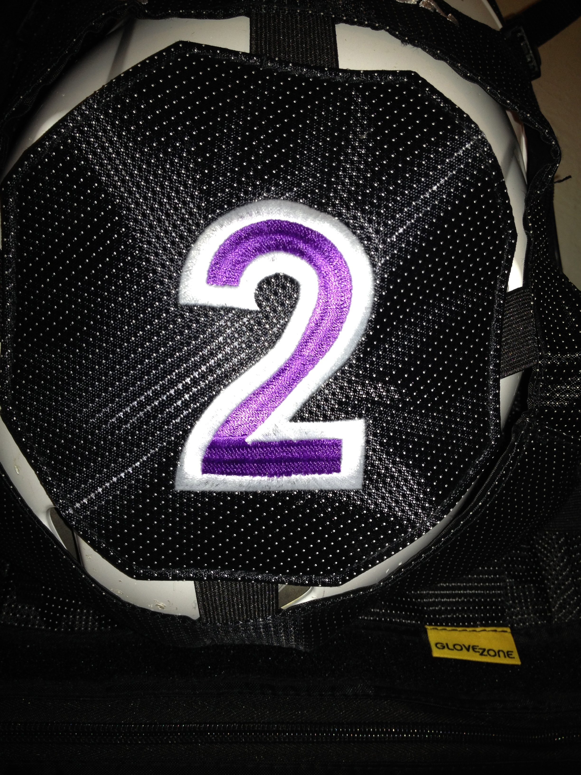
Saturday June 13, 2026
Beresford, SD
3-Game Guarantee
Entry Fee: $150
4 Brand New Fields (6 total fields)

Team Name: ___________________________________________________
Coaches Name:_________________________________________________
Address:_______________________________________________________
Phone (evening):________________________________________________
Cell:___________________________________________________________
Email:_________________________________________________________
Check One: ______9-10’s Baseball Team _____11-12’s Baseball Team
Tournament Contact: Scott Klungseth – Tournament Director
605-228-3540 scott.klungseth@dsu.edu
Please mail complete form and fee (make checks payable to” Jack Lawrence Memorial Fund”)
Scott Klungseth
908 Prairie Park Dr.
Beresford SD 57004

